**Selenium webdriver integration:**

We have to download plugin manager jar file for jmeter and add plugin manager to jmeter.

Installation and Usage

Download the Plugins Manager [JAR file](https://jmeter-plugins.org/get/) and put it into JMeter's lib/ext directory

<https://jmeter-plugins.org/wiki/PluginsManager/>

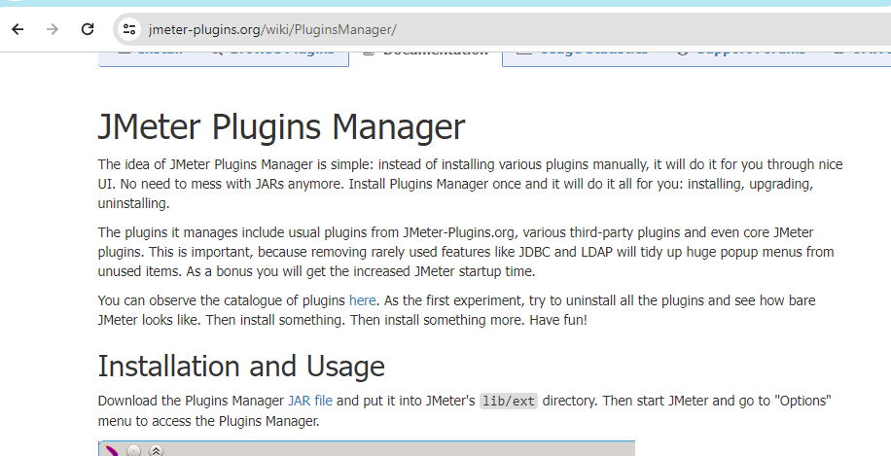

By clicking on the Jar it will download the jar file ,and it will show in the download folders.

Copy this in jmeter folder- lib-ext folder

Stop and restart jmeter

In Jmeter -go to Options - you will see the Plugin Manager

Click on plugin manager-go to available plugins -search for selenium webdriver support plugin

Click on Apply changes and restart jmeter

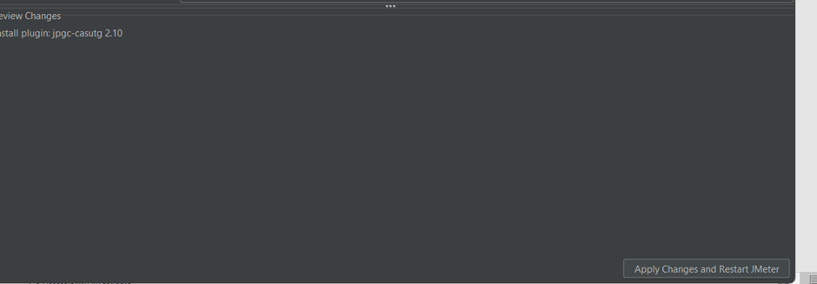

Now we can see in config the selenium drivers are added to the thread and we can access the browsers.

After this we can now add selenium configuration in jmeter.